|  |  |
| --- | --- |
|  | Technical Specification  ***Laptop*** |

|  |  |
| --- | --- |
|  | Date |

|  |  |  |  |
| --- | --- | --- | --- |
| Reference | **Technical Specification LAPTOP** | | |
| Summary |  | | |
| Project | **Laptop (SEA 6.3.1)** | | |
| System |  | | |
| Document perimeter | **Model** | | |
| Variant |  | | |
| History |  |  |  | |

|  |  |
| --- | --- |
| Approvals |  |

|  |  |  |  |  |
| --- | --- | --- | --- | --- |
| Validation |  |  |  |  |

|  |  |
| --- | --- |
| Contributors |  |

Table of Contents

1. Supervise data 3

History 3

Description 6

Diagram 7

Specification 7

2. Ensure cooling management 21

History 21

Description 22

Diagram 22

Specification 22

4. Manage MMI 25

History 25

Description 25

Diagram 26

Specification 26

5. Communicate 28

History 28

Description 29

Diagram 29

Specification 29

6. Store data 32

History 32

Description 33

Diagram 33

Specification 33

7. Manage physical parameters 37

History 37

Description 39

Diagram 40

Specification 40

# 1. Supervise data

## History

|  |  |  |  |  |
| --- | --- | --- | --- | --- |
| History | | | | |
| **Version** | **Date** | **Modification description** | | **Author** |
| 1.0 | **2025-08-14 01:44:26** | ADD Object | States and Modes[Requirement] (#- -> #1.0 [Release Chain Document: "1. Supervise data", Rev# 1.0]) | **samuel_eval** |
| Standby[Requirement] (#- -> #1.3) |
| Shutdown[Requirement] (#- -> #1.3) |
| Restart[Requirement] (#- -> #1.3) |
| Physical shutdown[Requirement] (#- -> #1.2) |
| Hibernate[Requirement] (#- -> #1.2) |
| CF system protection[Requirement] (#- -> #1.0 [Release Chain Document: "1. Supervise data", Rev# 1.0]) |
| Antivirus update[Requirement] (#- -> #1.3) |
| Antivirus install[Requirement] (#- -> #1.2) |
| 2.0 | **2025-08-14 01:57:07** | ADD Object | control component availablity[Requirement] (#- -> #1.1) | **samuel_eval** |
| [Processor Frequency] over 1,5 GHz[Requirement] (#- -> #1.0 [Release Chain Document: "1. Supervise data", Rev# 2.0]) |
| [CoreNumber] equals {1, 2, 4}[Requirement] (#- -> #1.0 [Release Chain Document: "1. Supervise data", Rev# 2.0]) |
| Switch user[Requirement] (#- -> #1.3) |
| Switch ON-OFF the Laptop[Requirement] (#- -> #2.1) |
| Support results stream[Requirement] (#- -> #1.0 [Release Chain Document: "1. Supervise data", Rev# 2.0]) |
| Support power modes[Requirement] (#- -> #1.0 [Release Chain Document: "1. Supervise data", Rev# 2.0]) |
| Support execution of programs[Requirement] (#- -> #1.0 [Release Chain Document: "1. Supervise data", Rev# 2.0]) |
| Support User identification[Requirement] (#- -> #1.0 [Release Chain Document: "1. Supervise data", Rev# 2.0]) |
| Support Man Machine Interface[Requirement] (#- -> #1.0 [Release Chain Document: "1. Supervise data", Rev# 2.0]) |
| Screen size of 15''[Requirement] (#- -> #1.0 [Release Chain Document: "1. Supervise data", Rev# 2.0]) |
| Response time of 20 ms[Requirement] (#- -> #1.0 [Release Chain Document: "1. Supervise data", Rev# 2.0]) |
| Realize [ProcessorFrequency] operation[Requirement] (#- -> #1.0 [Release Chain Document: "1. Supervise data", Rev# 2.0]) |
| Provide support for displaying information to User[Requirement] (#- -> #1.0 [Release Chain Document: "1. Supervise data", Rev# 2.0]) |
| Provide screen interface[Requirement] (#- -> #1.0 [Release Chain Document: "1. Supervise data", Rev# 2.0]) |
| Provide graphic display output[Requirement] (#- -> #1.0 [Release Chain Document: "1. Supervise data", Rev# 2.0]) |
| Processor frequency chosen _ 1,6GHz nominal, 2,6 GHz max[Requirement] (#- -> #1.0 [Release Chain Document: "1. Supervise data", Rev# 2.0]) |
| Processor core number chosen _ 2[Requirement] (#- -> #1.0 [Release Chain Document: "1. Supervise data", Rev# 2.0]) |
| Power execution[Requirement] (#- -> #1.3) |
| Personalize session[Requirement] (#- -> #1.3) |
| Performances data to display[Requirement] (#- -> #1.0 [Release Chain Document: "1. Supervise data", Rev# 2.0]) |
| Password protection[Requirement] (#- -> #1.3) |
| Obtain programs results[Requirement] (#- -> #1.0 [Release Chain Document: "1. Supervise data", Rev# 2.0]) |
| Multi-users[Requirement] (#- -> #1.3) |
| Manage heat (see MF4)[Requirement] (#- -> #1.0 [Release Chain Document: "1. Supervise data", Rev# 2.0]) |
| Manage 3D display[Requirement] (#- -> #1.0 [Release Chain Document: "1. Supervise data", Rev# 2.0]) |
| MF1 - provide a mobile support to execute programs[Requirement] (#- -> #1.0 [Release Chain Document: "1. Supervise data", Rev# 2.0]) |
| Improve the thread level parallelism with [CoreNumber][Requirement] (#- -> #1.0 [Release Chain Document: "1. Supervise data", Rev# 2.0]) |
| Fulfilled processor requirements[Requirement] (#- -> #1.0 [Release Chain Document: "1. Supervise data", Rev# 2.0]) |
| Execute instructions[Requirement] (#- -> #1.0 [Release Chain Document: "1. Supervise data", Rev# 2.0]) |
| Enter data from user[Requirement] (#- -> #1.0 [Release Chain Document: "1. Supervise data", Rev# 2.0]) |
| Ensure a collaborative work between components[Requirement] (#- -> #1.0 [Release Chain Document: "1. Supervise data", Rev# 2.0]) |
| Convert data to display[Requirement] (#- -> #1.0 [Release Chain Document: "1. Supervise data", Rev# 2.0]) |
| Connect the subsystems[Requirement] (#- -> #1.0 [Release Chain Document: "1. Supervise data", Rev# 2.0]) |
| Connect the devices (see MF5)[Requirement] (#- -> #1.0 [Release Chain Document: "1. Supervise data", Rev# 2.0]) |
| Bring power (see MF2)[Requirement] (#- -> #1.0 [Release Chain Document: "1. Supervise data", Rev# 2.0]) |
| [Laptop shall provide feedback to User about start sequence][Refine] (#- -> #1.0 [Release Chain Document: "1. Supervise data", Rev# 2.0]) |
| [Laptop shall control that components are available][Refine] (#- -> #1.0 [Release Chain Document: "STEP 1 Charge modification", Rev# 5.0]) |
| [Laptop shall boot quickly][Refine] (#- -> #1.0 [Release Chain Document: "STEP 1 Charge modification", Rev# 5.0]) |
| Provide graphic display output[Refine] (#- -> #1.0 [Release Chain Document: "1. Supervise data", Rev# 2.0]) |

## Description

Supervise data

**Description:**  
This function is responsible for supervise data. It plays a key role in the laptop’s overall performance and reliability.

Below is an illustrative image:



## Diagram

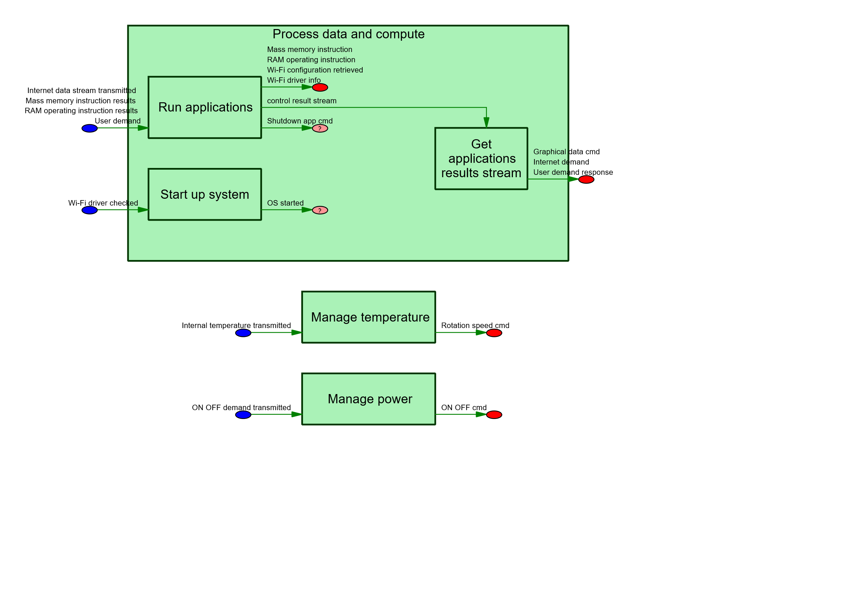

## Specification

|  |  |  |  |  |  |  |  |  |  |
| --- | --- | --- | --- | --- | --- | --- | --- | --- | --- |
| Level 1 | Level 2 | Level 3 | Level 4 | Level 5 | Level 6 | Level 7 | Type | Revision | desc |
| **1. Supervise data** |  |  |  |  |  |  | Flow Chain | 2.0 |  |
| 1. Supervise data | **CF system protection** |  |  |  |  |  | Requirement | 1.0 |  |
| 1. Supervise data | CF system protection | **Antivirus install** |  |  |  |  | Requirement | 1.2 | The LapTop shall warn user he should install another antivirus |
| 1. Supervise data | CF system protection | **Antivirus update** |  |  |  |  | Requirement | 1.3 | The antivirus shall be updated automatically |
| 1. Supervise data | **MF1 - provide a mobile support to execute programs** |  |  |  |  |  | Requirement | 1.0 |  |
| 1. Supervise data | MF1 - provide a mobile support to execute programs | **Ensure a collaborative work between components** |  |  |  |  | Requirement | 1.0 |  |
| 1. Supervise data | MF1 - provide a mobile support to execute programs | Ensure a collaborative work between components | **Connect the devices (see MF5)** |  |  |  | Requirement | 1.0 |  |
| 1. Supervise data | MF1 - provide a mobile support to execute programs | Ensure a collaborative work between components | **Connect the subsystems** |  |  |  | Requirement | 1.0 |  |
| 1. Supervise data | MF1 - provide a mobile support to execute programs | **Enter data from user** |  |  |  |  | Requirement | 1.0 |  |
| 1. Supervise data | MF1 - provide a mobile support to execute programs | **Provide support for displaying information to User** |  |  |  |  | Requirement | 1.0 |  |
| 1. Supervise data | MF1 - provide a mobile support to execute programs | Provide support for displaying information to User | **[Laptop shall provide feedback to User about start sequence]** |  |  |  | Refine | 1.0 |  |
| 1. Supervise data | MF1 - provide a mobile support to execute programs | Provide support for displaying information to User | **Convert data to display** |  |  |  | Requirement | 1.0 |  |
| 1. Supervise data | MF1 - provide a mobile support to execute programs | Provide support for displaying information to User | Convert data to display | **Performances data to display** |  |  | Requirement | 1.0 |  |
| 1. Supervise data | MF1 - provide a mobile support to execute programs | Provide support for displaying information to User | **Provide graphic display output** |  |  |  | Requirement | 1.0 |  |
| 1. Supervise data | MF1 - provide a mobile support to execute programs | Provide support for displaying information to User | Provide graphic display output | **Provide graphic display output** |  |  | Refine | 1.0 |  |
| 1. Supervise data | MF1 - provide a mobile support to execute programs | Provide support for displaying information to User | **Provide screen interface** |  |  |  | Requirement | 1.0 | The system shall provide a screen interface |
| 1. Supervise data | MF1 - provide a mobile support to execute programs | Provide support for displaying information to User | Provide screen interface | **Response time of 20 ms** |  |  | Requirement | 1.0 | The system shall have a response time for displaying the result screen lower than 20 ms |
| 1. Supervise data | MF1 - provide a mobile support to execute programs | Provide support for displaying information to User | Provide screen interface | **Screen size of 15''** |  |  | Requirement | 1.0 | The system shall have a screen size of 15'' |
| 1. Supervise data | MF1 - provide a mobile support to execute programs | **Support execution of programs** |  |  |  |  | Requirement | 1.0 |  |
| 1. Supervise data | MF1 - provide a mobile support to execute programs | Support execution of programs | **control component availablity** |  |  |  | Requirement | 1.1 |  |
| 1. Supervise data | MF1 - provide a mobile support to execute programs | Support execution of programs | control component availablity | **[Laptop shall control that components are available]** |  |  | Refine | 1.0 |  |
| 1. Supervise data | MF1 - provide a mobile support to execute programs | Support execution of programs | **Execute instructions** |  |  |  | Requirement | 1.0 |  |
| 1. Supervise data | MF1 - provide a mobile support to execute programs | Support execution of programs | Execute instructions | **Fulfilled processor requirements** |  |  | Requirement | 1.0 |  |
| 1. Supervise data | MF1 - provide a mobile support to execute programs | Support execution of programs | Execute instructions | Fulfilled processor requirements | **Processor core number chosen _ 2** |  | Requirement | 1.0 |  |
| 1. Supervise data | MF1 - provide a mobile support to execute programs | Support execution of programs | Execute instructions | Fulfilled processor requirements | **Processor frequency chosen _ 1,6GHz nominal, 2,6 GHz max** |  | Requirement | 1.0 |  |
| 1. Supervise data | MF1 - provide a mobile support to execute programs | Support execution of programs | Execute instructions | **Improve the thread level parallelism with [CoreNumber]** |  |  | Requirement | 1.0 |  |
| 1. Supervise data | MF1 - provide a mobile support to execute programs | Support execution of programs | Execute instructions | Improve the thread level parallelism with [CoreNumber] | **[CoreNumber] equals {1, 2, 4}** |  | Requirement | 1.0 | The system shall improve the thread level parallelism with a core number equals to [CoreNumber] |
| 1. Supervise data | MF1 - provide a mobile support to execute programs | Support execution of programs | Execute instructions | **Power execution** |  |  | Requirement | 1.3 | User shall be able to manage Laptop power consumption and manage OS start/stop |
| 1. Supervise data | MF1 - provide a mobile support to execute programs | Support execution of programs | Execute instructions | Power execution | **Bring power (see MF2)** |  | Requirement | 1.0 |  |
| 1. Supervise data | MF1 - provide a mobile support to execute programs | Support execution of programs | Execute instructions | Power execution | **Support power modes** |  | Requirement | 1.0 |  |
| 1. Supervise data | MF1 - provide a mobile support to execute programs | Support execution of programs | Execute instructions | Power execution | Support power modes | **Hibernate** | Requirement | 1.2 | the Laptop shall be able to hibernate |
| 1. Supervise data | MF1 - provide a mobile support to execute programs | Support execution of programs | Execute instructions | Power execution | Support power modes | **Physical shutdown** | Requirement | 1.2 |  |
| 1. Supervise data | MF1 - provide a mobile support to execute programs | Support execution of programs | Execute instructions | Power execution | Support power modes | **Restart** | Requirement | 1.3 | Laptop shall be able to restart |
| 1. Supervise data | MF1 - provide a mobile support to execute programs | Support execution of programs | Execute instructions | Power execution | Support power modes | **Shutdown** | Requirement | 1.3 | Laptop shall be able to shutdown |
| 1. Supervise data | MF1 - provide a mobile support to execute programs | Support execution of programs | Execute instructions | Power execution | Support power modes | **Standby** | Requirement | 1.3 | The Laptop shall have a standby state |
| 1. Supervise data | MF1 - provide a mobile support to execute programs | Support execution of programs | Execute instructions | **Realize [ProcessorFrequency] operation** |  |  | Requirement | 1.0 |  |
| 1. Supervise data | MF1 - provide a mobile support to execute programs | Support execution of programs | Execute instructions | Realize [ProcessorFrequency] operation | **[Processor Frequency] over 1,5 GHz** |  | Requirement | 1.0 | The system shall realize a number of operation by second higher than [ProcessorFrequency] |
| 1. Supervise data | MF1 - provide a mobile support to execute programs | Support execution of programs | **Manage heat (see MF4)** |  |  |  | Requirement | 1.0 |  |
| 1. Supervise data | MF1 - provide a mobile support to execute programs | Support execution of programs | **Obtain programs results** |  |  |  | Requirement | 1.0 |  |
| 1. Supervise data | MF1 - provide a mobile support to execute programs | Support execution of programs | **Support results stream** |  |  |  | Requirement | 1.0 |  |
| 1. Supervise data | MF1 - provide a mobile support to execute programs | Support execution of programs | **Switch ON-OFF the Laptop** |  |  |  | Requirement | 2.1 |  |
| 1. Supervise data | MF1 - provide a mobile support to execute programs | Support execution of programs | Switch ON-OFF the Laptop | **[Laptop shall boot quickly]** |  |  | Refine | 1.0 |  |
| 1. Supervise data | MF1 - provide a mobile support to execute programs | **Support Man Machine Interface** |  |  |  |  | Requirement | 1.0 |  |
| 1. Supervise data | MF1 - provide a mobile support to execute programs | Support Man Machine Interface | **Manage 3D display** |  |  |  | Requirement | 1.0 | The system shall manage 3D images displaying it correctly |
| 1. Supervise data | MF1 - provide a mobile support to execute programs | **Support User identification** |  |  |  |  | Requirement | 1.0 |  |
| 1. Supervise data | MF1 - provide a mobile support to execute programs | Support User identification | **Multi-users** |  |  |  | Requirement | 1.3 | The Laptop shall support multiple users |
| 1. Supervise data | MF1 - provide a mobile support to execute programs | Support User identification | Multi-users | **Password protection** |  |  | Requirement | 1.3 | each user shall be able to protect his data with a password |
| 1. Supervise data | MF1 - provide a mobile support to execute programs | Support User identification | Multi-users | **Personalize session** |  |  | Requirement | 1.3 | each user shall be able to personalize his session |
| 1. Supervise data | MF1 - provide a mobile support to execute programs | Support User identification | Multi-users | **Switch user** |  |  | Requirement | 1.3 | From within one users session, Laptop shall allow to switch to another user's session |
| 1. Supervise data | **States and Modes** |  |  |  |  |  | Requirement | 1.0 |  |
| 1. Supervise data | States and Modes | **Hibernate** |  |  |  |  | Requirement | 1.2 | the Laptop shall be able to hibernate |
| 1. Supervise data | States and Modes | **Physical shutdown** |  |  |  |  | Requirement | 1.2 |  |
| 1. Supervise data | States and Modes | **Restart** |  |  |  |  | Requirement | 1.3 | Laptop shall be able to restart |
| 1. Supervise data | States and Modes | **Shutdown** |  |  |  |  | Requirement | 1.3 | Laptop shall be able to shutdown |
| 1. Supervise data | States and Modes | **Standby** |  |  |  |  | Requirement | 1.3 | The Laptop shall have a standby state |
|  |  |  |  |  |  |  |  |  |  |

# 2. Ensure cooling management

## History

|  |  |  |  |  |
| --- | --- | --- | --- | --- |
| History | | | | |
| **Version** | **Date** | **Modification description** | | **Author** |
| 1.0 | **2025-08-14 02:01:59** | ADD Object | Provide cold for Laptop[Requirement] (#- -> #1.0 [Release Chain Document: "2. Ensure cooling management", Rev# 1.0]) | **samuel_eval** |
| Monitor the temperature[Requirement] (#- -> #1.0 [Release Chain Document: "2. Ensure cooling management", Rev# 1.0]) |
| Measure the processor temperature[Requirement] (#- -> #1.0 [Release Chain Document: "2. Ensure cooling management", Rev# 1.0]) |
| Manage Laptop subsystems cooling[Requirement] (#- -> #1.0 [Release Chain Document: "2. Ensure cooling management", Rev# 1.0]) |
| MF4 - Enable thermal management[Requirement] (#- -> #1.0 [Release Chain Document: "2. Ensure cooling management", Rev# 1.0]) |
| Have sufficient airflow to cool the processor[Requirement] (#- -> #1.0 [Release Chain Document: "2. Ensure cooling management", Rev# 1.0]) |
| Get airflow to cool the system[Requirement] (#- -> #1.0 [Release Chain Document: "2. Ensure cooling management", Rev# 1.0]) |
| Evacuate heat to environment[Requirement] (#- -> #1.0 [Release Chain Document: "2. Ensure cooling management", Rev# 1.0]) |
| Evacuate heat excess[Requirement] (#- -> #1.0 [Release Chain Document: "2. Ensure cooling management", Rev# 1.0]) |
| Battery heating[Requirement] (#- -> #1.0 [Release Chain Document: "2. Ensure cooling management", Rev# 1.0]) |

## Description

Ensure cooling management

**Description:**  
This function is responsible for ensure cooling management. It plays a key role in the laptop’s overall performance and reliability.

Below is an illustrative image:



## Diagram

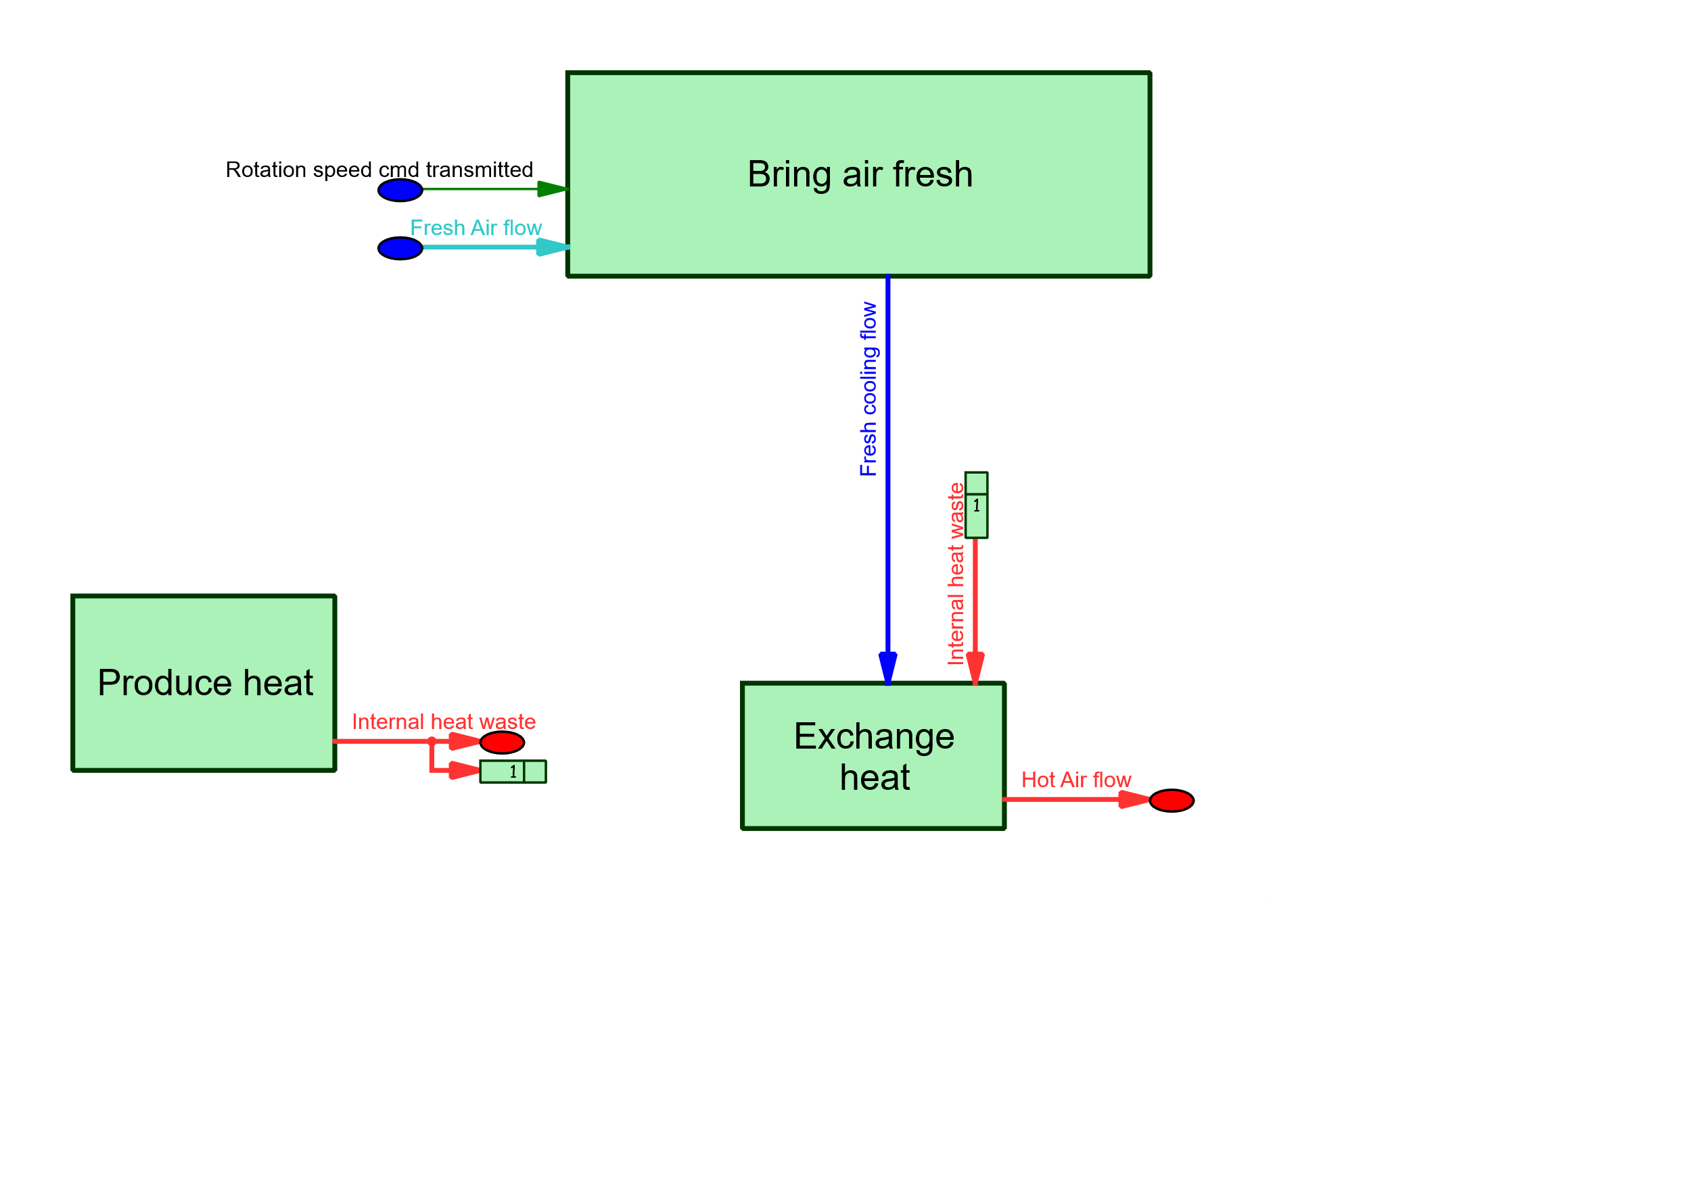

## Specification

|  |  |  |  |  |  |  |
| --- | --- | --- | --- | --- | --- | --- |
| Level 1 | Level 2 | Level 3 | Level 4 | Type | Revision | desc |
| **2. Ensure cooling management** |  |  |  | Flow Chain | 1.0 |  |
| 2. Ensure cooling management | **MF4 - Enable thermal management** |  |  | Requirement | 1.0 |  |
| 2. Ensure cooling management | MF4 - Enable thermal management | **Battery heating** |  | Requirement | 1.0 | Battery shall not overheat |
| 2. Ensure cooling management | MF4 - Enable thermal management | **Evacuate heat excess** |  | Requirement | 1.0 |  |
| 2. Ensure cooling management | MF4 - Enable thermal management | Evacuate heat excess | **Evacuate heat to environment** | Requirement | 1.0 | The system shall evacuate the heat that it produces to the environment. |
| 2. Ensure cooling management | MF4 - Enable thermal management | Evacuate heat excess | **Get airflow to cool the system** | Requirement | 1.0 |  |
| 2. Ensure cooling management | MF4 - Enable thermal management | Evacuate heat excess | **Provide cold for Laptop** | Requirement | 1.0 |  |
| 2. Ensure cooling management | MF4 - Enable thermal management | **Manage Laptop subsystems cooling** |  | Requirement | 1.0 |  |
| 2. Ensure cooling management | MF4 - Enable thermal management | Manage Laptop subsystems cooling | **Have sufficient airflow to cool the processor** | Requirement | 1.0 |  |
| 2. Ensure cooling management | MF4 - Enable thermal management | **Monitor the temperature** |  | Requirement | 1.0 |  |
| 2. Ensure cooling management | MF4 - Enable thermal management | Monitor the temperature | **Measure the processor temperature** | Requirement | 1.0 |  |
|  |  |  |  |  |  |  |

# 4. Manage MMI

## History

|  |  |  |  |  |  |  |  |  |  |  |  |  |
| --- | --- | --- | --- | --- | --- | --- | --- | --- | --- | --- | --- | --- |
| History | | | | | | | | | | | | |
| **Version** | | **Date** | | **Modification description** | | | | | | | **Author** | |
| 1.0 | | **2025-08-14 02:08:19** | | ADD Object | | Provide start and stop interface[Requirement] (#- -> #1.0 [Release Chain Document: "4. Manage MMI", Rev# 1.0]) | | | | | **samuel_eval** | |
| Provide keyboard interface[Requirement] (#- -> #1.0 [Release Chain Document: "4. Manage MMI", Rev# 1.0]) | | | | |
| Provide Mouse Interface[Requirement] (#- -> #1.0 [Release Chain Document: "4. Manage MMI", Rev# 1.0]) | | | | |
| Provide Interface for User Requests[Requirement] (#- -> #1.0 [Release Chain Document: "4. Manage MMI", Rev# 1.0]) | | | | |
| MF5 - Enable Users interaction[Requirement] (#- -> #1.0 [Release Chain Document: "4. Manage MMI", Rev# 1.0]) | | | | |
| [User shall have an interface to power on the Laptop][Refine] (#- -> #1.0 [Release Chain Document: "4. Manage MMI", Rev# 1.0]) | | | | |
| 2.0 | | **2025-08-14 02:12:28** | | MODIFY Object | | Provide keyboard interface[Requirement] (#1.0 -> #2.0 [Release Chain Document: "4. Manage MMI", Rev# 2.0]) | | | | | **samuel_eval** | |
| 3.0 | | **2025-08-14 02:13:57** | | MODIFY Object | | Provide Mouse Interface[Requirement] (#1.0 -> #2.0 [Release Chain Document: "4. Manage MMI", Rev# 3.0]) | | | | | **samuel_eval** | |
|  |  |  |  |  |  |  |  |  |  |  |  |  |

## Description

Manage MMI

**Description:**  
This function is responsible for manage mmi. It plays a key role in the laptop’s overall performance and reliability.

Below is an illustrative image:



## Diagram

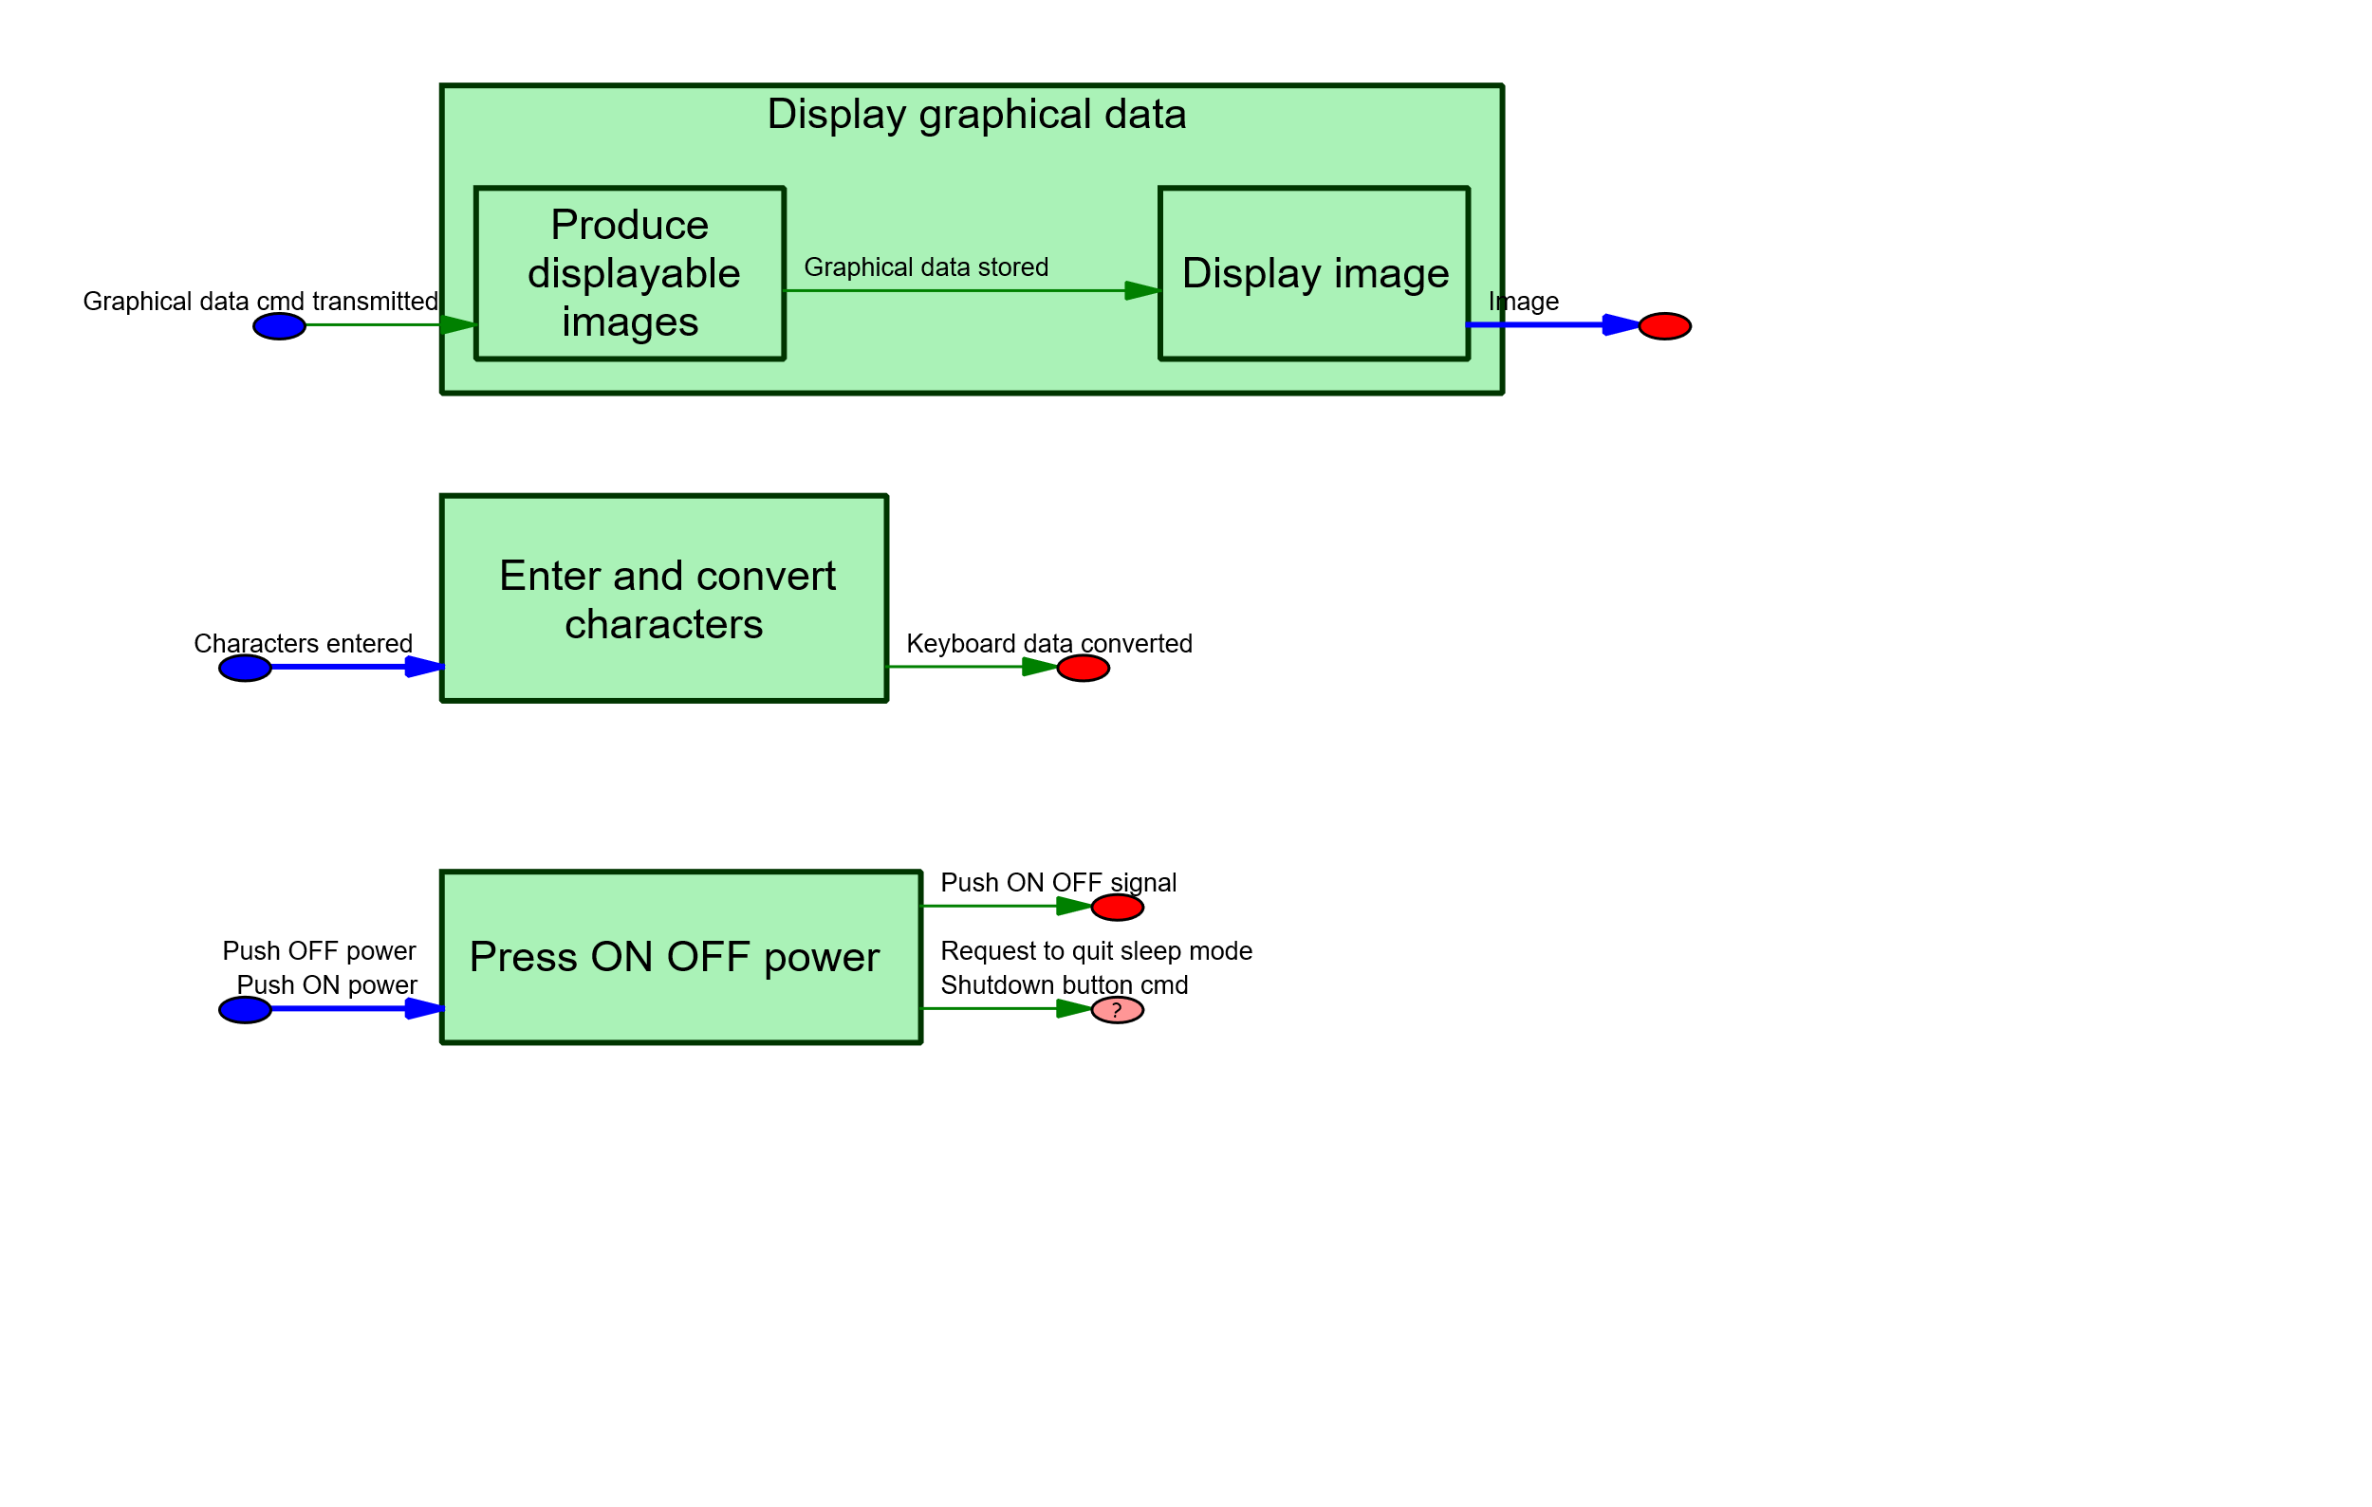

## Specification

|  |  |  |  |  |  |  |
| --- | --- | --- | --- | --- | --- | --- |
| Level 1 | Level 2 | Level 3 | Level 4 | Type | Revision | desc |
| **4. Manage MMI** |  |  |  | Flow Chain | 3.0 |  |
| 4. Manage MMI | **MF5 - Enable Users interaction** |  |  | Requirement | 1.0 |  |
| 4. Manage MMI | MF5 - Enable Users interaction | **Provide Interface for User Requests** |  | Requirement | 1.0 |  |
| 4. Manage MMI | MF5 - Enable Users interaction | Provide Interface for User Requests | **[User shall have an interface to power on the Laptop]** | Refine | 1.0 |  |
| 4. Manage MMI | MF5 - Enable Users interaction | Provide Interface for User Requests | **Provide keyboard interface** | Requirement | 2.0 | no desc |
| 4. Manage MMI | MF5 - Enable Users interaction | Provide Interface for User Requests | **Provide Mouse Interface** | Requirement | 2.0 | no desc |
| 4. Manage MMI | MF5 - Enable Users interaction | Provide Interface for User Requests | **Provide start and stop interface** | Requirement | 1.0 |  |
|  |  |  |  |  |  |  |

# 5. Communicate

## History

|  |  |  |  |  |  |  |  |  |  |  |  |  |
| --- | --- | --- | --- | --- | --- | --- | --- | --- | --- | --- | --- | --- |
| History | | | | | | | | | | | | |
| **Version** | | **Date** | | **Modification description** | | | | | | | **Author** | |
| 1.0 | | **2025-08-14 02:15:53** | | ADD Object | | Support wired internet connection[Requirement] (#- -> #1.0 [Release Chain Document: "5. Communicate", Rev# 1.0]) | | | | | **samuel_eval** | |
| Support internet signal[Requirement] (#- -> #1.0 [Release Chain Document: "5. Communicate", Rev# 1.0]) | | | | |
| Support execution of Browsers[Requirement] (#- -> #1.0 [Release Chain Document: "5. Communicate", Rev# 1.0]) | | | | |
| Support Wi-Fi connection[Requirement] (#- -> #1.3) | | | | |
| Support Ethernet connection[Requirement] (#- -> #1.2) | | | | |
| Manage internet data[Requirement] (#- -> #1.0 [Release Chain Document: "5. Communicate", Rev# 1.0]) | | | | |
| MF3 - Enable browsing on the Internet[Requirement] (#- -> #1.0 [Release Chain Document: "5. Communicate", Rev# 1.0]) | | | | |
| Enable http communication[Requirement] (#- -> #1.0 [Release Chain Document: "5. Communicate", Rev# 1.0]) | | | | |
| Area network - wifi[Refine] (#- -> #1.0 [Release Chain Document: "5. Communicate", Rev# 1.0]) | | | | |
| Area network - ethernet[Refine] (#- -> #1.0 [Release Chain Document: "5. Communicate", Rev# 1.0]) | | | | |
|  |  |  |  |  |  |  |  |  |  |  |  |  |

## Description

Communicate

**Description:**  
This function is responsible for communicate. It plays a key role in the laptop’s overall performance and reliability.

Below is an illustrative image:



## Diagram

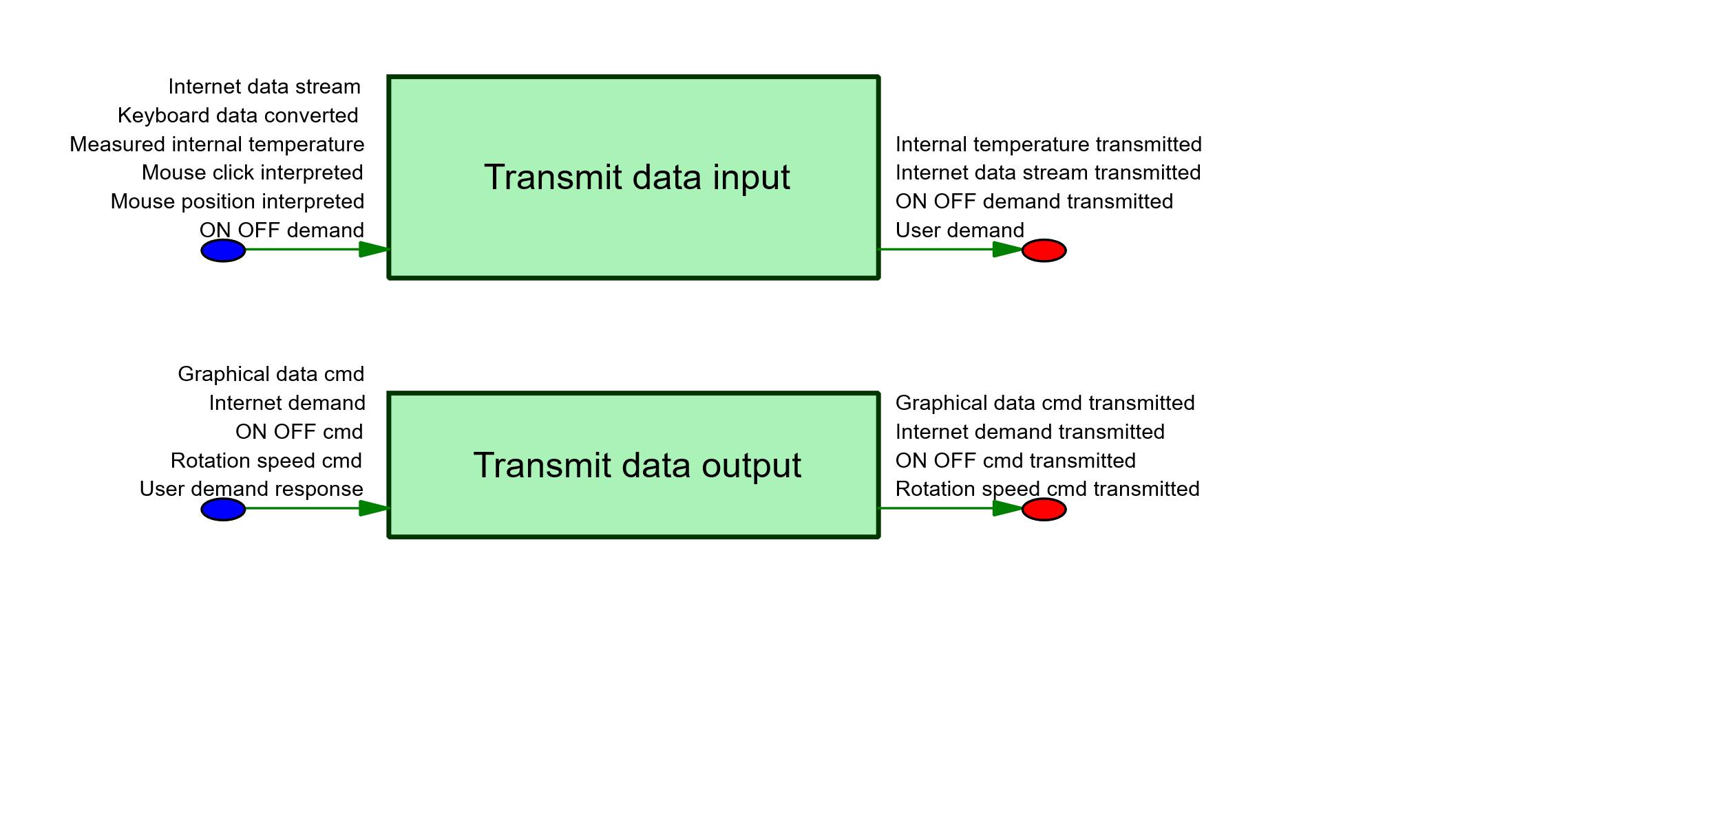

## Specification

|  |  |  |  |  |  |  |  |
| --- | --- | --- | --- | --- | --- | --- | --- |
| Level 1 | Level 2 | Level 3 | Level 4 | Level 5 | Type | Revision | desc |
| **5. Communicate** |  |  |  |  | Flow Chain | 1.0 |  |
| 5. Communicate | **MF3 - Enable browsing on the Internet** |  |  |  | Requirement | 1.0 |  |
| 5. Communicate | MF3 - Enable browsing on the Internet | **Enable http communication** |  |  | Requirement | 1.0 |  |
| 5. Communicate | MF3 - Enable browsing on the Internet | Enable http communication | **Support Ethernet connection** |  | Requirement | 1.2 | LapTop has to be able to connect to Network using ethernet cable |
| 5. Communicate | MF3 - Enable browsing on the Internet | Enable http communication | Support Ethernet connection | **Area network - ethernet** | Refine | 1.0 |  |
| 5. Communicate | MF3 - Enable browsing on the Internet | Enable http communication | **Support Wi-Fi connection** |  | Requirement | 1.3 | LapTop has to be able to connect to WiFi network |
| 5. Communicate | MF3 - Enable browsing on the Internet | Enable http communication | Support Wi-Fi connection | **Area network - wifi** | Refine | 1.0 |  |
| 5. Communicate | MF3 - Enable browsing on the Internet | **Manage internet data** |  |  | Requirement | 1.0 |  |
| 5. Communicate | MF3 - Enable browsing on the Internet | Manage internet data | **Support internet signal** |  | Requirement | 1.0 |  |
| 5. Communicate | MF3 - Enable browsing on the Internet | Manage internet data | **Support wired internet connection** |  | Requirement | 1.0 |  |
| 5. Communicate | MF3 - Enable browsing on the Internet | **Support execution of Browsers** |  |  | Requirement | 1.0 |  |
|  |  |  |  |  |  |  |  |

# 6. Store data

## History

|  |  |  |  |  |  |  |  |  |  |  |  |  |
| --- | --- | --- | --- | --- | --- | --- | --- | --- | --- | --- | --- | --- |
| History | | | | | | | | | | | | |
| **Version** | | **Date** | | **Modification description** | | | | | | | **Author** | |
| 1.0 | | **2025-08-14 02:17:53** | | ADD Object | | [RAM_MemorySize] over 2000[Requirement] (#- -> #1.0 [Release Chain Document: "6. Store data", Rev# 1.0]) | | | | | **samuel_eval** | |
| [RAM_LatencyTime] below 3[Requirement] (#- -> #1.0 [Release Chain Document: "6. Store data", Rev# 1.0]) | | | | |
| RAM[Requirement] (#- -> #1.0 [Release Chain Document: "6. Store data", Rev# 1.0]) | | | | |
| RAM [RAM_MemorySize][Requirement] (#- -> #1.0 [Release Chain Document: "6. Store data", Rev# 1.0]) | | | | |
| RAM [RAM_LatencyTime][Requirement] (#- -> #1.0 [Release Chain Document: "6. Store data", Rev# 1.0]) | | | | |
| Memory quantity[Requirement] (#- -> #1.0 [Release Chain Document: "6. Store data", Rev# 1.0]) | | | | |
| MF1 - provide a mobile support to execute programs[Requirement] (#- -> #1.0 [Release Chain Document: "1. Supervise data", Rev# 2.0]) | | | | |
| Lasting memory[Requirement] (#- -> #1.0 [Release Chain Document: "6. Store data", Rev# 1.0]) | | | | |
| Lasting memory latency time[Requirement] (#- -> #1.0 [Release Chain Document: "6. Store data", Rev# 1.0]) | | | | |
| Lasting memory data quantity[Requirement] (#- -> #1.0 [Release Chain Document: "6. Store data", Rev# 1.0]) | | | | |
|  |  |  |  |  |  |  |  |  |  |  |  |  |

## Description

Store data

**Description:**  
This function is responsible for store data. It plays a key role in the laptop’s overall performance and reliability.

Below is an illustrative image:



## Diagram

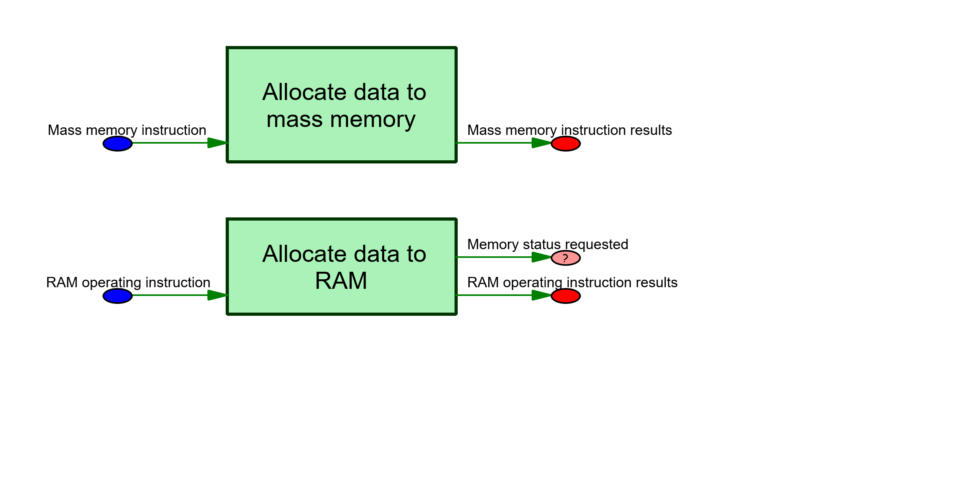

## Specification

|  |  |  |  |  |  |  |  |  |
| --- | --- | --- | --- | --- | --- | --- | --- | --- |
| Level 1 | Level 2 | Level 3 | Level 4 | Level 5 | Level 6 | Type | Revision | desc |
| **6. Store data** |  |  |  |  |  | Flow Chain | 1.0 |  |
| 6. Store data | **MF1 - provide a mobile support to execute programs** |  |  |  |  | Requirement | 1.0 |  |
| 6. Store data | MF1 - provide a mobile support to execute programs | **Memory quantity** |  |  |  | Requirement | 1.0 |  |
| 6. Store data | MF1 - provide a mobile support to execute programs | Memory quantity | **Lasting memory** |  |  | Requirement | 1.0 |  |
| 6. Store data | MF1 - provide a mobile support to execute programs | Memory quantity | Lasting memory | **Lasting memory data quantity** |  | Requirement | 1.0 | The system shall have a RAM data quantity of some hundreds of Go. |
| 6. Store data | MF1 - provide a mobile support to execute programs | Memory quantity | Lasting memory | **Lasting memory latency time** |  | Requirement | 1.0 | The system shall have a RAM latency time (or "access time") of some milliseconds. |
| 6. Store data | MF1 - provide a mobile support to execute programs | Memory quantity | **RAM** |  |  | Requirement | 1.0 | The system shall have a RAM (live memory) |
| 6. Store data | MF1 - provide a mobile support to execute programs | Memory quantity | RAM | **RAM [RAM_LatencyTime]** |  | Requirement | 1.0 | The system shall have a latency time of at least [RAM_LatencyTime] (10^-6 ). |
| 6. Store data | MF1 - provide a mobile support to execute programs | Memory quantity | RAM | RAM [RAM_LatencyTime] | **[RAM_LatencyTime] below 3** | Requirement | 1.0 |  |
| 6. Store data | MF1 - provide a mobile support to execute programs | Memory quantity | RAM | **RAM [RAM_MemorySize]** |  | Requirement | 1.0 | The system shall have a memory size of at least [RAM_MemorySize] (Mo). |
| 6. Store data | MF1 - provide a mobile support to execute programs | Memory quantity | RAM | RAM [RAM_MemorySize] | **[RAM_MemorySize] over 2000** | Requirement | 1.0 | The system shall have a memory size of at least 2000 (Mo). |
|  |  |  |  |  |  |  |  |  |

# 7. Manage physical parameters

## History

|  |  |  |  |  |  |  |  |  |  |  |  |  |
| --- | --- | --- | --- | --- | --- | --- | --- | --- | --- | --- | --- | --- |
| History | | | | | | | | | | | | |
| **Version** | | **Date** | | **Modification description** | | | | | | | **Author** | |
| 1.0 | | **2025-08-14 02:19:45** | | ADD Object | | [RAM_MemorySize] over 2000[Requirement] (#- -> #1.0 [Release Chain Document: "6. Store data", Rev# 1.0]) | | | | | **samuel_eval** | |
| [RAM_LatencyTime] below 3[Requirement] (#- -> #1.0 [Release Chain Document: "6. Store data", Rev# 1.0]) | | | | |
| RAM[Requirement] (#- -> #1.0 [Release Chain Document: "6. Store data", Rev# 1.0]) | | | | |
| RAM [RAM_MemorySize][Requirement] (#- -> #1.0 [Release Chain Document: "6. Store data", Rev# 1.0]) | | | | |
| RAM [RAM_LatencyTime][Requirement] (#- -> #1.0 [Release Chain Document: "6. Store data", Rev# 1.0]) | | | | |
| Provide sufficient autonomy[Requirement] (#- -> #1.0 [Release Chain Document: "7. Manage physical parameters", Rev# 1.0]) | | | | |
| Provide internet connection (see MF3)[Requirement] (#- -> #1.0 [Release Chain Document: "7. Manage physical parameters", Rev# 1.0]) | | | | |
| Memory quantity[Requirement] (#- -> #1.0 [Release Chain Document: "6. Store data", Rev# 1.0]) | | | | |
| MF1 - provide a mobile support to execute programs[Requirement] (#- -> #1.0 [Release Chain Document: "1. Supervise data", Rev# 2.0]) | | | | |
| Lasting memory[Requirement] (#- -> #1.0 [Release Chain Document: "6. Store data", Rev# 1.0]) | | | | |
| Lasting memory latency time[Requirement] (#- -> #1.0 [Release Chain Document: "6. Store data", Rev# 1.0]) | | | | |
| Lasting memory data quantity[Requirement] (#- -> #1.0 [Release Chain Document: "6. Store data", Rev# 1.0]) | | | | |
| Ensure a collaborative work between components[Requirement] (#- -> #1.0 [Release Chain Document: "1. Supervise data", Rev# 2.0]) | | | | |
| Connect the subsystems[Requirement] (#- -> #1.0 [Release Chain Document: "1. Supervise data", Rev# 2.0]) | | | | |
| Connect the devices (see MF5)[Requirement] (#- -> #1.0 [Release Chain Document: "1. Supervise data", Rev# 2.0]) | | | | |
| CF usage and mission profiles[Requirement] (#- -> #1.0 [Release Chain Document: "7. Manage physical parameters", Rev# 1.0]) | | | | |
| CF Diagnostic, reprogramming, configuation[Requirement] (#- -> #1.0 [Release Chain Document: "7. Manage physical parameters", Rev# 1.0]) | | | | |
| Air temperature lower than 45°C[Requirement] (#- -> #1.0 [Release Chain Document: "7. Manage physical parameters", Rev# 1.0]) | | | | |
| Air temperature range[Refine] (#- -> #1.0 [Release Chain Document: "7. Manage physical parameters", Rev# 1.0]) | | | | |
|  |  |  |  |  |  |  |  |  |  |  |  |  |
|  |  |  |  |  |  |  |  |  |  |  |  |  |
| Validation | | | | | | | | | | | | |
| **Version** | | **Review date** | | **Review animator** | | | **Verifiers** | | | **Validators** | | |
|  | |  | |  | | |  | | |  | | |
|  | |  | |  | | |  | | |  | | |
|  | |  | |  | | |  | | |  | | |
|  |  |  |  |  |  |  |  |  |  |  |  |  |

## Description

Manage physical parameters

**Description:**  
This function is responsible for manage physical parameters. It plays a key role in the laptop’s overall performance and reliability.

Below is an illustrative image:



## Diagram

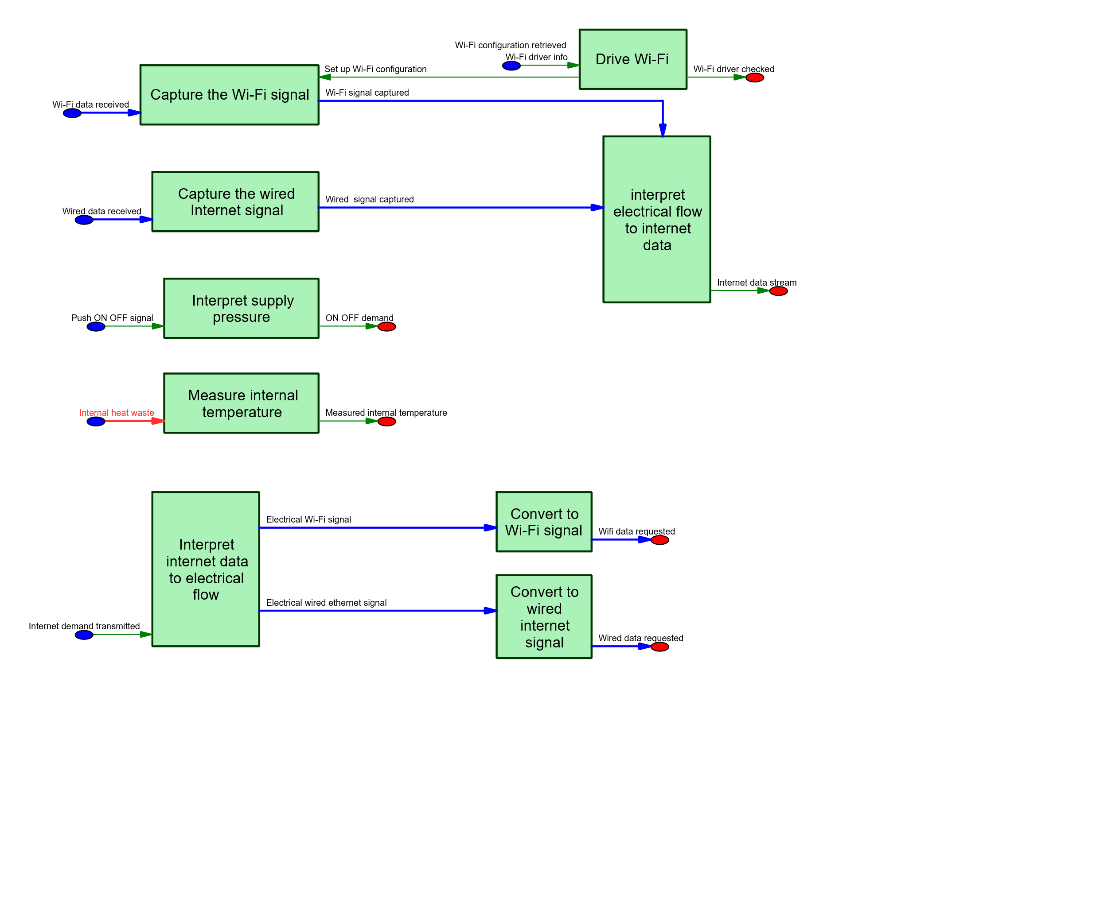

## Specification

|  |  |  |  |  |  |  |  |  |
| --- | --- | --- | --- | --- | --- | --- | --- | --- |
| Level 1 | Level 2 | Level 3 | Level 4 | Level 5 | Level 6 | Type | Revision | desc |
| **7. Manage physical parameters** |  |  |  |  |  | Flow Chain | 1.0 |  |
| 7. Manage physical parameters | **CF Diagnostic, reprogramming, configuation** |  |  |  |  | Requirement | 1.0 |  |
| 7. Manage physical parameters | **CF usage and mission profiles** |  |  |  |  | Requirement | 1.0 |  |
| 7. Manage physical parameters | CF usage and mission profiles | **Air temperature lower than 45°C** |  |  |  | Requirement | 1.0 |  |
| 7. Manage physical parameters | CF usage and mission profiles | Air temperature lower than 45°C | **Air temperature range** |  |  | Refine | 1.0 |  |
| 7. Manage physical parameters | **MF1 - provide a mobile support to execute programs** |  |  |  |  | Requirement | 1.0 |  |
| 7. Manage physical parameters | MF1 - provide a mobile support to execute programs | **Ensure a collaborative work between components** |  |  |  | Requirement | 1.0 |  |
| 7. Manage physical parameters | MF1 - provide a mobile support to execute programs | Ensure a collaborative work between components | **Connect the devices (see MF5)** |  |  | Requirement | 1.0 |  |
| 7. Manage physical parameters | MF1 - provide a mobile support to execute programs | Ensure a collaborative work between components | **Connect the subsystems** |  |  | Requirement | 1.0 |  |
| 7. Manage physical parameters | MF1 - provide a mobile support to execute programs | **Memory quantity** |  |  |  | Requirement | 1.0 |  |
| 7. Manage physical parameters | MF1 - provide a mobile support to execute programs | Memory quantity | **Lasting memory** |  |  | Requirement | 1.0 |  |
| 7. Manage physical parameters | MF1 - provide a mobile support to execute programs | Memory quantity | Lasting memory | **Lasting memory data quantity** |  | Requirement | 1.0 | The system shall have a RAM data quantity of some hundreds of Go. |
| 7. Manage physical parameters | MF1 - provide a mobile support to execute programs | Memory quantity | Lasting memory | **Lasting memory latency time** |  | Requirement | 1.0 | The system shall have a RAM latency time (or "access time") of some milliseconds. |
| 7. Manage physical parameters | MF1 - provide a mobile support to execute programs | Memory quantity | **RAM** |  |  | Requirement | 1.0 | The system shall have a RAM (live memory) |
| 7. Manage physical parameters | MF1 - provide a mobile support to execute programs | Memory quantity | RAM | **RAM [RAM_LatencyTime]** |  | Requirement | 1.0 | The system shall have a latency time of at least [RAM_LatencyTime] (10^-6 ). |
| 7. Manage physical parameters | MF1 - provide a mobile support to execute programs | Memory quantity | RAM | RAM [RAM_LatencyTime] | **[RAM_LatencyTime] below 3** | Requirement | 1.0 |  |
| 7. Manage physical parameters | MF1 - provide a mobile support to execute programs | Memory quantity | RAM | **RAM [RAM_MemorySize]** |  | Requirement | 1.0 | The system shall have a memory size of at least [RAM_MemorySize] (Mo). |
| 7. Manage physical parameters | MF1 - provide a mobile support to execute programs | Memory quantity | RAM | RAM [RAM_MemorySize] | **[RAM_MemorySize] over 2000** | Requirement | 1.0 | The system shall have a memory size of at least 2000 (Mo). |
| 7. Manage physical parameters | MF1 - provide a mobile support to execute programs | **Provide internet connection (see MF3)** |  |  |  | Requirement | 1.0 |  |
| 7. Manage physical parameters | MF1 - provide a mobile support to execute programs | **Provide sufficient autonomy** |  |  |  | Requirement | 1.0 |  |
|  |  |  |  |  |  |  |  |  |